Childhood Obesity Causes & Consequences

On This Page

* [Behavior](https://www.cdc.gov/obesity/childhood/causes.html#Behavior)
* [Community Environment](https://www.cdc.gov/obesity/childhood/causes.html#Community)
* [Consequences of Obesity](https://www.cdc.gov/obesity/childhood/causes.html#Consequences)
* [References](https://www.cdc.gov/obesity/childhood/causes.html#References)

Childhood obesity is a complex health issue. It occurs when a child is well above the normal or healthy weight for his or her age and height. The causes of excess weight gain in young people are similar to those in adults, including behavior and genetics. Obesity is also influenced by a person’s community as it can affect the ability to make healthy choices.

Behavior

Behaviors that influence excess weight gain include eating high-calorie, low-nutrient foods and beverages, medication use and sleep routines. Not getting enough physical activity and spending too much time on sedentary activities such as watching television or other screen devices can lead to weight gain.



In contrast, consuming healthy foods and being physically active can help children grow and maintain a healthy weight. Balancing energy or calories consumed from foods and beverages with the calories burned through activity plays a role in preventing excess weight gain. In addition, eating healthy foods and being physically active helps to prevent chronic diseases such as type 2 diabetes, some cancers, and heart disease.

Use these resources to eat well and be active!

A healthy diet follows the 2020-2025 [Dietary Guidelines for Americansexternal icon](https://www.dietaryguidelines.gov/).It emphasizes eating a variety of vegetables and fruits, whole grains, a variety of lean protein foods, and low-fat and fat-free dairy products. It also recommends limiting foods and beverages with added sugars, solid fats, or sodium.

The [*Physical Activity Guidelines for Americansexternal icon*](https://health.gov/our-work/physical-activity/current-guidelines) recommends children aged 6 – 17 years do at least 60 minutes of moderate to vigorous physical activity every day. Children aged 3 through 5 years should be physically active throughout the day for growth and development.

See tips to [help children maintain a healthy weight](https://www.cdc.gov/healthyweight/children/index.html).

[Top of Page](https://www.cdc.gov/obesity/childhood/causes.html)



Community Environment

It can be difficult to make healthy food choices and get enough physical activity in environments that do not support healthy habits. Places such as childcare centers, schools, or communities can affect diet and activity through the foods and drinks they offer and the opportunities for physical activity they provide. Other community factors include the affordability of healthy food options, peer and social supports, marketing and promotion, and policies that determine how a community is designed.

Consequences of Obesity

More Immediate Health Risks

Obesity during childhood can harm the body in a variety of ways. Children who have obesity are more likely to have:(1-7)

* High blood pressure and high cholesterol, which are risk factors for cardiovascular disease.
* Increased risk of impaired glucose tolerance, insulin resistance, and type 2 diabetes.
* Breathing problems, such as asthma and sleep apnea.
* Joint problems and musculoskeletal discomfort.
* Fatty liver disease, gallstones, and gastro-esophageal reflux (i.e., heartburn).



Childhood obesity is also related to8-10:

* Psychological problems such as anxiety and depression.
* Low self-esteem and lower self-reported quality of life.
* Social problems such as bullying and stigma.

Future Health Risks

* Children who have obesity are more likely to become adults with obesity.11 Adult obesity is associated with increased risk of several serious health conditions including heart disease, type 2 diabetes, and cancer.12
* If children have obesity, their obesity and disease risk factors in adulthood are likely to be more severe.13

**What are the treatments for obesity?**

* [Dietary changes](https://www.medicalnewstoday.com/articles/323691#dietary-changes)
* [Physical activity](https://www.medicalnewstoday.com/articles/323691#physical-activity)
* [Medications](https://www.medicalnewstoday.com/articles/323691#medications)
* [Surgery](https://www.medicalnewstoday.com/articles/323691#surgery)
* [Hormonal treatment](https://www.medicalnewstoday.com/articles/323691#hormonal-treatment)
* [Browning white fat cells](https://www.medicalnewstoday.com/articles/323691#browning-white-fat-cells)
* [Health risks and weight](https://www.medicalnewstoday.com/articles/323691#health-risks-and-weight)
* [Takeaway](https://www.medicalnewstoday.com/articles/323691#takeaway)

Obesity can happen for a number of reasons, including diet, a sedentary lifestyle, genetic factors, a health condition, or the use of certain medications. A number of treatment options can help people to achieve and maintain a suitable weight.

Carrying excess weight can increase the risk of a number of health problems. Losing weight can be frustrating and difficult, but even losing just [5–10 percentTrusted Source](https://www.cdc.gov/healthyweight/losing_weight/index.html) of [body weight](https://www.medicalnewstoday.com/info/obesity/how-much-should-i-weigh.php) can bring significant health benefits, according to the Centers for Disease Control and Prevention (CDC).

For a person who weighs 250 pounds (lb), or 114 kilograms (kg) this would mean losing 12–25 lb, or 5.7–11.4 kg. A small reduction in weight is an important achievement.

Losing weight slowly and constantly, for example, 1–2 lb each week, is often better than losing a lot quickly, because it is more likely to stay off once a person reaches their target weight.

Exercise and dietary changes are useful weight-loss tools. For some people, however, these are not effective. In this case, medication or surgery might be an option.

Sometimes, a health condition — such as a hormonal problem — [can result](https://www.thyroid.org/patient-thyroid-information/ct-for-patients/september-2016/vol-9-issue-9-p-11/) in weight gain. In this case, treating the imbalance can help to solve the problem.

**1. Dietary changes**

Share on PinterestReplacing high-fat foods with more fruits and vegetables can help a person to lose weight.

One reason why excess weight and fat accumulate is when a person consumes more [calories](https://www.medicalnewstoday.com/articles/245588.php) than they use. Over time, this can lead to weight gain.

Some types of food are more likely to lead to weight gain. Some processed foods contain additives, such as high-fructose corn syrup. This can cause changes in the body that result in additional weight gain.

Reducing the intake of processed, refined, and ready-made food that is high in sugar and fat, while increasing the consumption of whole grains and other high-fiber foods — such as fresh fruits and vegetables — can help a person to lose weight.

One advantage of a high-fiber diet is that the body [feels full](http://www.heart.org/en/healthy-living/healthy-eating/losing-weight/fiber-up-slim-down) more quickly, making it less tempting to eat more. Whole grains help a person to feel full for longer, because they release their energy more slowly.

Fiber and whole grains can also help to reduce the risk of a number of conditions related to metabolic syndrome.

Metabolic syndrome is a condition that involves a number of health problems, including [type 2 diabetes](https://www.medicalnewstoday.com/info/diabetes/type2diabetes.php), [high blood pressure](https://www.medicalnewstoday.com/articles/159283.php), and cardiovascular problems. It is more common in people with [obesity](https://www.medicalnewstoday.com/info/obesity/how-much-should-i-weigh.php).

A doctor or dietitian can help to suggest a strategy and possibly a suitable weight-loss program.

**Avoid crash-dieting**

Trying to lose weight quickly by crash-dieting carries the following risks:

* New health problems may develop.
* [Vitamin](https://www.medicalnewstoday.com/articles/195878.php) deficiencies can occur.
* It is more difficult to achieve healthy weight loss.

In some cases, a doctor may suggest that a person with severe obesity should follow a very low-calorie liquid diet. A health professional should monitor this strategy to ensure that the person remains safe while following the diet.

**2. Physical activity**

Share on PinterestClimbing the stairs instead of taking the elevator can be good exercise.

While the body does burn some calories even when a person is just sitting or sleeping, for most people, the more active they are, the more calories the body will burn.

However, this can take time. To lose one pound of fat, a person needs to burn 3,500 calories.

Good ways to start getting active include:

* walking briskly
* swimming
* using the stairs instead of the elevator
* getting off the bus or train one stop earlier and walking the rest of the way

Doing chores such as gardening, housework, or walking the dog all contribute.

The CDC suggest doing [60–90 minutesTrusted Source](https://www.cdc.gov/healthyweight/losing_weight/index.html) of moderately intense activity most days of the week.

People who are not used to exercising or who find it difficult to be active due to health or mobility problems should speak to a health professional about how to exercise and how to get started.

A person who is not in the habit of exercising should not start with too strenuous an activity, as this could pose a health risk.

**3. Weight-loss medications**

A doctor will sometimes prescribe medication, such as orlastat (Xenical) to help a person lose weight.

However, they usually only do this if:

* dietary changes and exercise have not resulted in weight loss
* the person’s weight poses a significant risk to their health

The [National Institutes of Health](https://dailymed.nlm.nih.gov/dailymed/drugInfo.cfm?setid=5bbdc95b-82a1-4ba5-8185-6504ff68cc06) note that people should use medication alongside a reduced-calorie diet. Orlastat does not replace lifestyle changes.

Side effects include gastrointestinal symptoms, such as fatty stool and increased or decreased defecation. Some people have reported unwanted effects on the respiratory system, muscles and joints, [headaches](https://www.medicalnewstoday.com/articles/73936.php), and others.

From 1997 to 2010, doctors were able to prescribe sibutramine, too, but the United States Food and Drug Administration (FDA) [withdrew approval](https://livertox.nih.gov/Sibutramine.htm) in 2010, due to concerns about serious adverse effects.

[powered by Rubicon Project](https://rubiconproject.com/?utm_source=ad%20unit&utm_campaign=outstream)

**4. Surgery**

Weight loss, or bariatric, surgery involves removing or changing a part of a person’s stomach or small intestine so that they do not consume as much food or absorb as many calories as before.

This can help an individual to lose weight and also reduce the risk of high blood pressure, type 2 diabetes, and other aspects of metabolic syndrome that can occur with obesity.

Surgery [can either](https://www.niddk.nih.gov/health-information/weight-management/bariatric-surgery/types) make the stomach smaller, or it can bypass part of the digestive system.

**Gastric sleeve or gastric band**

The surgeon uses a gastric sleeve or a [gastric band](https://www.medicalnewstoday.com/articles/298313.php) to make the stomach smaller.

After the operation, a person cannot consume more than about one cup of food during each sitting. This significantly reduces food intake.

**Gastric bypass**

The procedure enables food to bypass parts of the digestive system, specifically the first part of the mid-section of the small intestine. It may also reduce the size of the stomach.

This is generally more effective than restrictive procedures, but there is a higher risk of vitamin and mineral deficiencies, as the body can no longer absorb as many nutrients.

A doctor may recommend surgery for a person who has a [BMI](https://www.medicalnewstoday.com/info/obesity/what-is-bmi.php) of [30 or above](https://asmbs.org/resources/asmbs-updated-position-statement-on-bariatric-surgery-in-class-i-obesity), depending on their individual needs.

These include:

* whether or not they have complications due to obesity
* the effectiveness of non-surgical treatments they have already undertaken

Surgeons often do bariatric surgery as a laparoscopic, or keyhole procedure.

**5. Hormonal treatment**

Hormonal treatment might one day help people with obesity. Scientists who published a [studyTrusted Source](https://www.ncbi.nlm.nih.gov/pmc/articles/PMC3871274/" \t "_blank) in 2014 noted that part of the success of bariatric surgery may be the impact it has on gut hormones.

Harnessing these hormones could lead to novel, non-surgical options.

The researchers suggest that combining certain hormones might provide an effective therapy.

Top of Form

MEDICAL NEWS TODAY NEWSLETTER

**Knowledge is power. Get our free daily newsletter.**

Dig deeper into the health topics you care about most. Subscribe to our facts-first newsletter today.

Enter your email

SIGN UP NOW

Your [privacy](https://www.medicalnewstoday.com/privacy-policy) is important to us

Bottom of Form

**6. Browning white fat cells**

Humans and other mammals contain two types of fat cell:

* Brown-fat cells burn calories and produce heat.
* White-fat cells store calories.

Scientists have been looking for ways to reprogram white-fat cells so that they behave more like brown-fat cells. They call this “beiging” fat cells.

If they can do this, they might be able to produce a therapy that can cause the body to burn fat more quickly.

Experts do not yet know how to achieve this, but a research team who published a [reviewTrusted Source](https://www.ncbi.nlm.nih.gov/pmc/articles/PMC5627770/" \t "_blank) in *Nature Reviews Molecular Cell Biology* expressed hope that new genetic tools in the pipeline might hold the key.

**Health risks and weight**

Obesity increases the risk of a number of health problems.

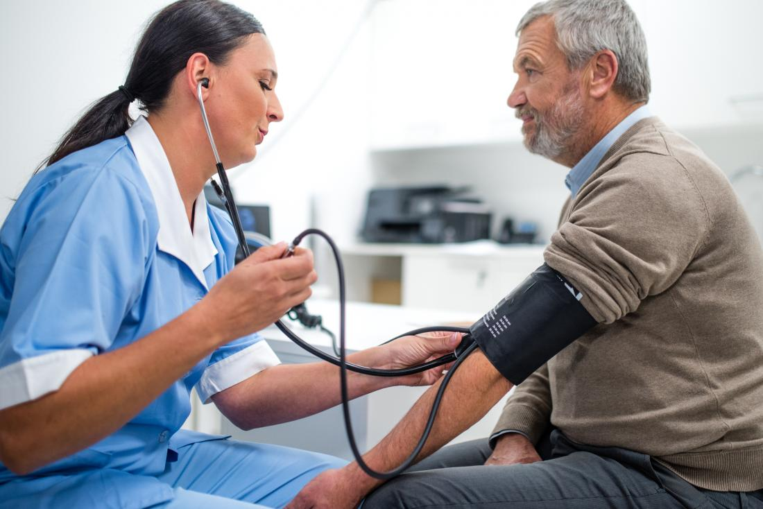Share on PinterestHigh blood pressure is one aspect of metabolic syndrome.

Some of these — such as type 2 diabetes, cardiovascular disease, and high blood pressure — come under the umbrella of metabolic syndrome, a collection of features that often occur together, frequently with excess weight and obesity.

Health risks that increase with obesity include:

**Osteoarthritis**: Additional strain on the joints can lead to bone and cartilage degeneration.

**Coronary heart disease**: Heart disease becomes more likely when a person carries extra weight. This is often due to high [cholesterol](https://www.medicalnewstoday.com/articles/9152.php) levels and the extra weight putting additional strain on the heart and blood vessels.

**Gallbladder disease**: Consuming foods that are high in sugar and fat may not necessarily lead to obesity, but it can cause the liver to overproduce cholesterol, resulting in [gallstones](https://www.medicalnewstoday.com/articles/153981.php).

**High blood pressure**: Excess adipose tissue in the body may secrete substances that affect the kidneys. This can result in high blood pressure, or [hypertension](https://www.medicalnewstoday.com/articles/150109.php). The body may also produce extra [insulin](https://www.medicalnewstoday.com/info/diabetes/whatisinsulin.php), and this, too, can raise [blood pressure](https://www.medicalnewstoday.com/articles/270644.php).

**Respiratory problems**: These can occur if the extra weight puts pressure on the lungs, reducing the space available for breathing.

**Several cancers**: According to the CDC, [13 typesTrusted Source](https://www.cdc.gov/media/releases/2017/p1003-vs-cancer-obesity.html) of [cancer](https://www.medicalnewstoday.com/info/cancer-oncology/) become more likely to occur if a person has obesity, including [colorectal cancer](https://www.medicalnewstoday.com/articles/155598.php).

**Sleep apnea**: The National Heart, Lung, and Blood Institute (NHLBI) note that weight reduction [often improvesTrusted Source](https://www.nhlbi.nih.gov/health/educational/lose_wt/onepound.htm) the symptoms of sleep apnea.

**Stroke**: Obesity often develops alongside a buildup of cholesterol. In time, this increases the risk of blockages in the blood vessels. These, in turn, can lead to [heart disease](https://www.medicalnewstoday.com/articles/237191.php) and [stroke](https://www.medicalnewstoday.com/articles/7624.php).

**Type 2 diabetes**: This is a key aspect of metabolic syndrome.

**Takeaway**

Help is available for people who are concerned that they have too much weight. A change in diet and increase in exercise can help in many cases.

If these do not work, a doctor may be able to recommend another solution.

[](https://activation.healthline.com/api/member-offers/2487/redirect?lp=466&tc=120291&subid2=/articles/323691&subid=noom_mnt_obesity_bot_3092&correlationId=945117bc-296c-4621-8604-5cb44684621a)

ADVERTISEMENT